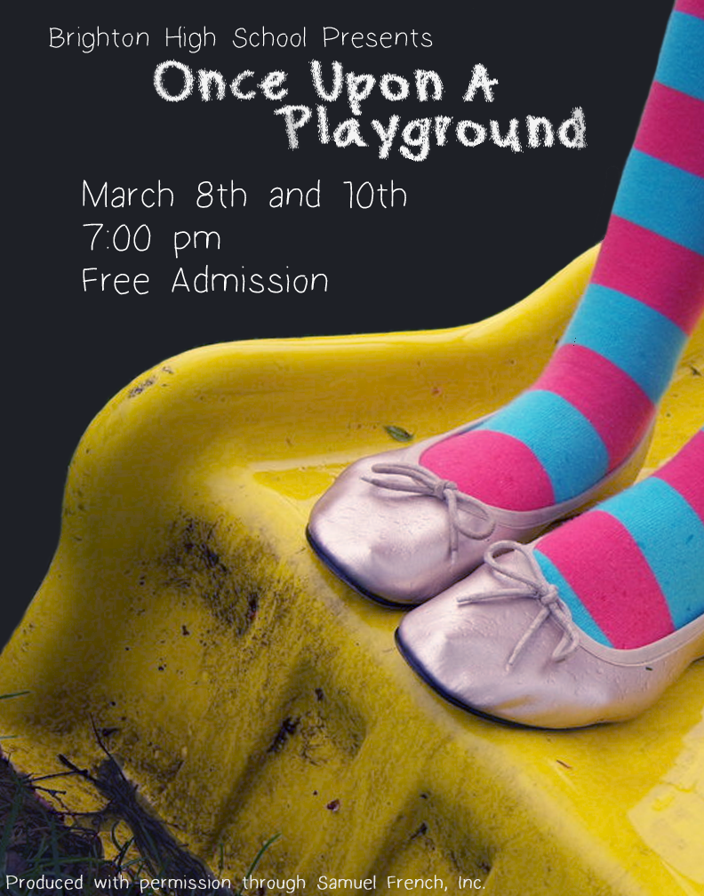
Cast
Wanda Bun………………………………..........Emma Jones
Tootie Shoe…………………………...…Kathleen Donnelly
Didi Fee………………………………………….Coco Barth
Forda Moore…………………………………….Kate Abbott
Pheobe Dive………………………………….Alex Kohlburn
Dixie Wicks………………………………...Nathan Gallardo
Flirt Stevens…………………………………...Richard Tyler
Georgie…………………...…………………….Ryan Ashby
The Girl……………………...………………Renae Nickens
The Boy………………………………………….Jesse Lowe
Twitch……..……...………………………….Leah Coleman
Ted Stinson……………………………………..Jaron Allred
Foster Holmes………………………………Spencer Hamby

Crew
Director……………...………………………….Kate Abbott
Director………………………………………Alex Kohlburn
Advisor………………………………………..Katie Thames
Set Design…………………………………..Morgan Stevens
Stage Manager………………………………….Ryan Ashby
Costume Design……………...…………………Kate Abbott
Sound Designer………………………………...Patrick Pope
Light Designer……………………………….Renae Nickens
ATTCD………………………………………Adam Witbeck
ATTA…………………………………………..Chase Green
Playgrounds Favorite Techie…………………...Jack Koncar
Light Op………………………………………. Emily White
Graphic Designer………………………………Emily White
Publicity……………………………………..Eliza Jeanfreau

Special Thanks
BHS Administration
BHS Custodial Staff
The Stevens Family
The wonderful parents and guardians of our cast and crew
Christian Winwood
Sam D’Antuono

